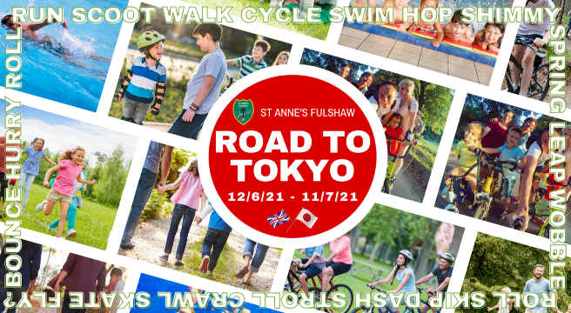

Road to Tokyo - Running Events

Family Events
- Saturday 12th June 2pm: Peat Moss 5km Circular leaving from school
- Sunday 4th July 9am: Wilmslow Junior Parkrun 2km meet at the Carrs Park near Café Azul.
- Depending on attendance/success of Saturday 12th June event, we may schedule another family event on weekend of 26th/27th June.

Children must be accompanied by a responsible adult, group leaders cannot be responsible for children other than our own.

Adult Events
- Friday 18th June- Bollin Valley 10km
- Monday 21st June- 5km around Peat Moss
- Thursday 24th June- 10km
- Thursday 1st July- 5km around Peat Moss
- Friday 2nd July- 10km
- Wednesday 7th July- 10 Mile

Adult runs will all be straight from morning school drop off. Runs will all be sociable and nobody will be left behind. Please bring water on hot days.

If you aren’t sure whether any of these events are for you, or if have any further questions then please feel free to get in touch with Rachael Thomas, Vicky Wilson or Nicola Aslam, or email pta@stannesfulshaw.net. Join the running WhatsApp group for more updates - https://chat.whatsapp.com/Cin2MIoZui9I4nTGALY0q0.

